**User Data:**

**Signup:**

**DELIMITER $$**

**create procedure signup(in Userid varchar(20),in uname varchar(20),in email varchar(30),**

**in yob year(4),in city varchar(20),in pwd varchar(20),in starttime datetime,in lastlogin datetime,**

**inout flag int)**

**begin**

**declare count int default 0;**

**select count(*) into count from user where user.userid= Userid;**

**if count<1 then**

**insert into user values(Userid,uname,email,yob,city,pwd,starttime,lastlogin);**

**else set flag=1;**

**end if;**

**end $$**

**DELIMITER ;**

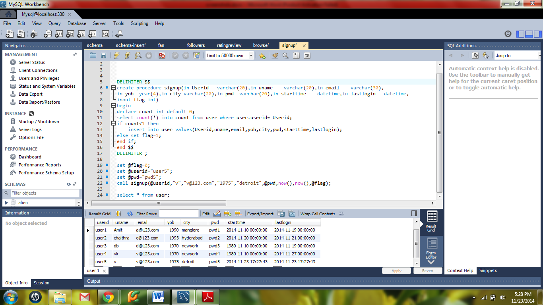

**Create or edit personal profile:**

**DELIMITER $$**

**create procedure create_or_edit_personal(**

**in User varchar(20),**

**in username varchar(20),**

**in yr year(4),**

**in ucity varchar(20),**

**in pswd varchar(20),**

**inout update_user_flag int)**

**begin**

**if update_user_flag=1 then**

**update user set uname = username , yob = yr, city = ucity, pwd = pswd where userid=User;**

**end if;**

**end $$**

**DELIMITER ;**

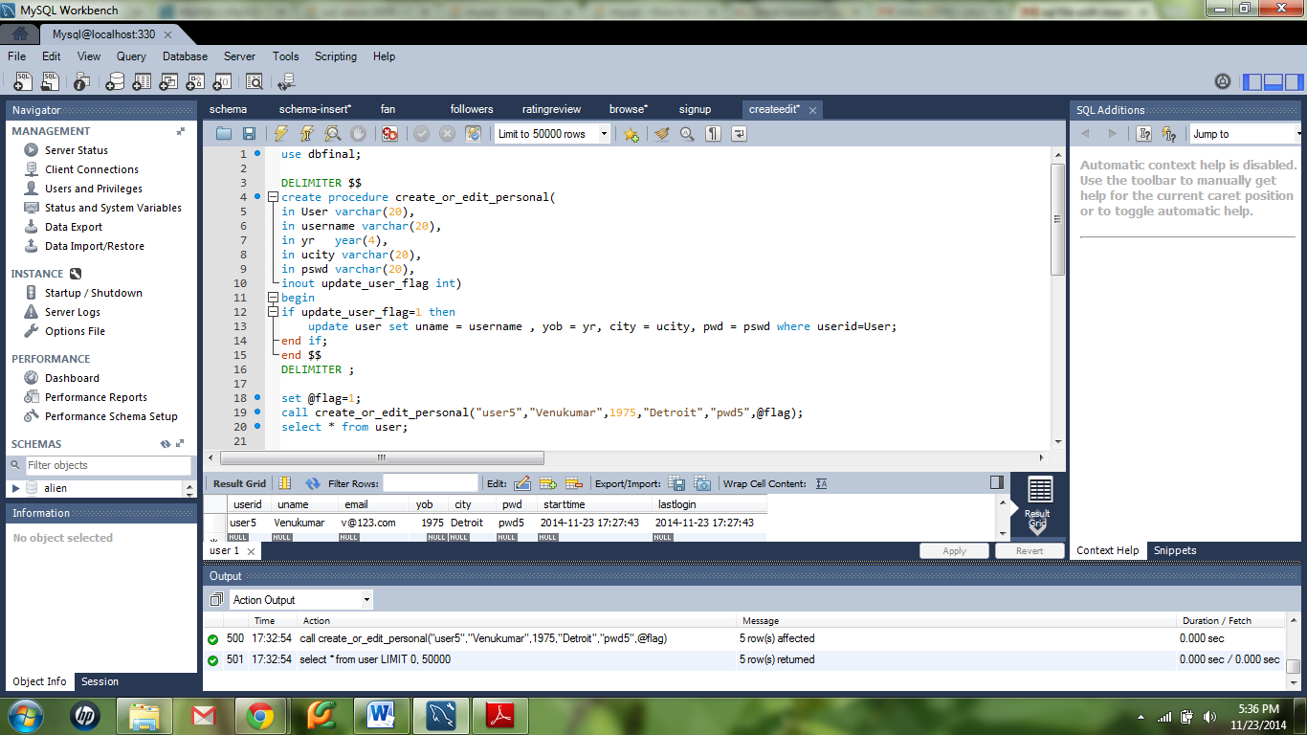

**Create or edit interests:**

**DELIMITER $$**

**create procedure create_or_edit_interests(**

**in User varchar(20),**

**in G varchar(20),**

**inout update_user_flag int)**

**begin**

**declare count int default 0;**

**select count(*) into count from genre_user g where g.userid = User and g.gid=G;**

**if update_user_flag=0 and count<1 then**

**set update_user_flag=2;**

**insert into genre_user values(User,G,now());**

**elseif update_user_flag=1 then**

**set update_user_flag=3;**

**delete from genre_user where userid=User and gid=G;**

**end if;**

**end $$**

**DELIMITER ;**

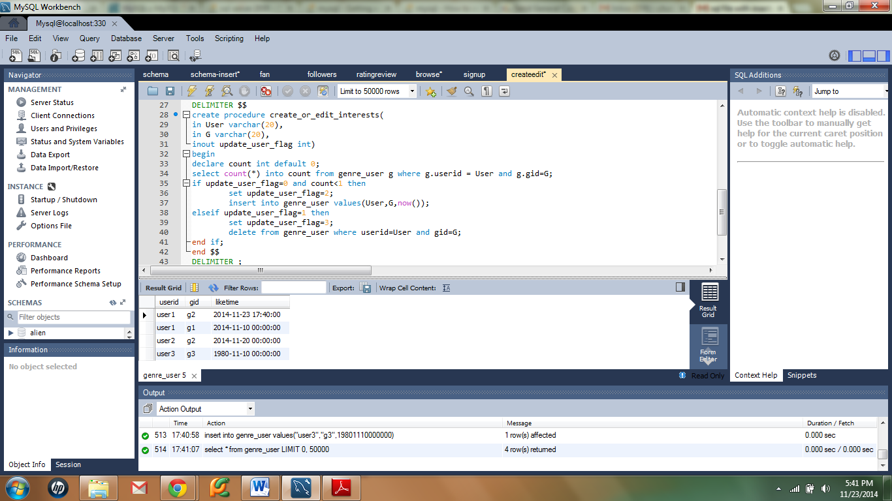

**To become a fan of a band:**

**DELIMITER $$**

**CREATE PROCEDURE fan (in user varchar(20),in band varchar(20),inout flag int)**

**BEGIN**

**declare count int default 0;**

**select count(*) into count from user_band u where u.userid=user and u.bid=band;**

**if count<1 and flag=0 then**

**insert into user_band values(user,band,now());**

**elseif count>0 and flag=1 then**

**delete from user_band where userid=user and bid=band;**

**end if;**

**END $$;**

**DELIMITER ;**

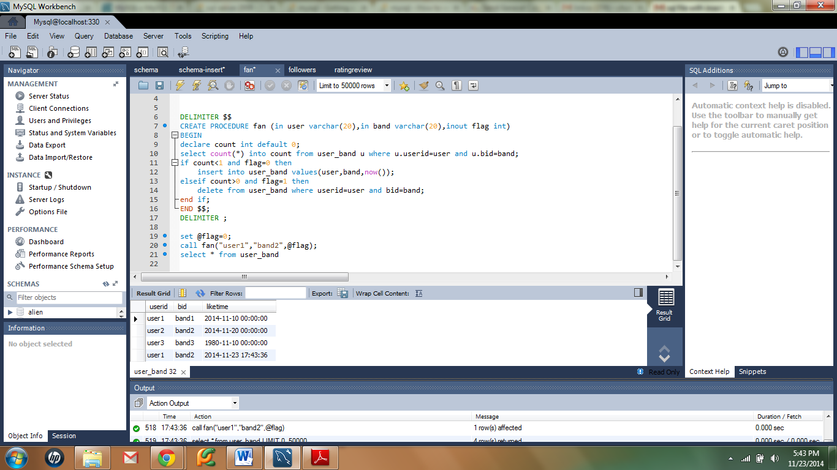

**To follow another user:**

**DELIMITER $$**

**CREATE PROCEDURE add_or_remove_follower(In follower varchar(20), in following varchar(20), inout flag int)**

**BEGIN**

**declare count int default 0;**

**select count(*) into count from followers f where f.followerid=follower and f.followingid=following;**

**if count<1 and flag = 0 then**

**insert into followers values(follower,following,now());**

**elseif count>0 and flag = 1 then**

**delete from followers where followerid=follower and followingid=following;**

**end if;**

**END $$**

**DELIMITER ;**

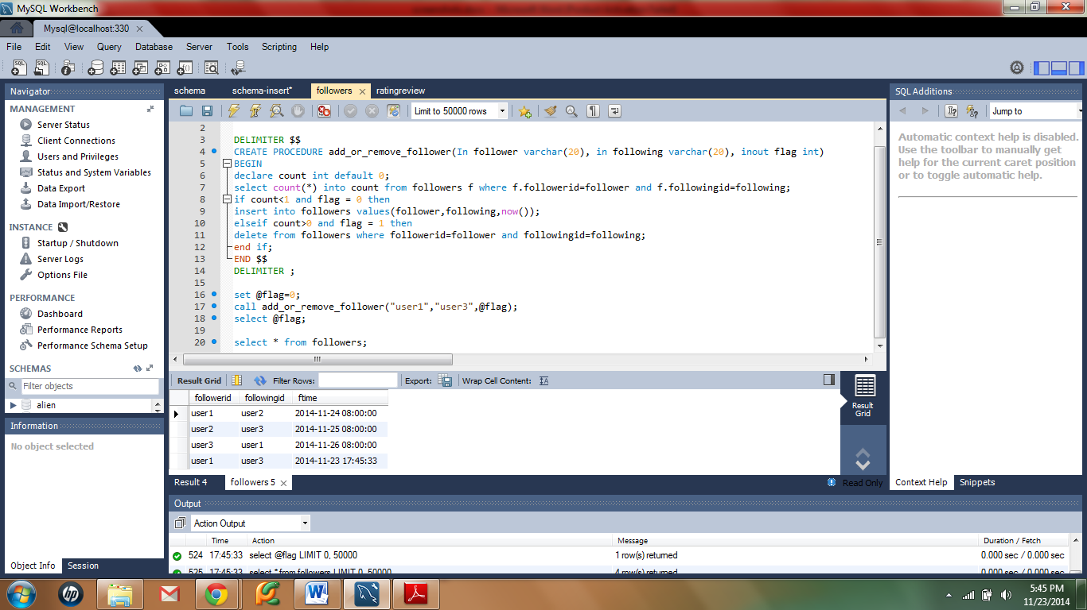

**To rate and review a concert:**

**DELIMITER $$**

**CREATE PROCEDURE add_or_remove_rating(In user varchar(20), in concert varchar(20), in rate int, comments varchar(30),inout flag int)**

**BEGIN**

**declare count int default 0;**

**select count(*) into count from user_rating r where r.userid=user and r.cid=concert;**

**if count<1 and flag = 0 then**

**insert into user_rating values(user,concert,rate,comments,now());**

**elseif count>0 and flag = 1 then**

**delete from user_rating where userid=user and cid=concert;**

**end if;**

**END $$**

**DELIMITER ;**

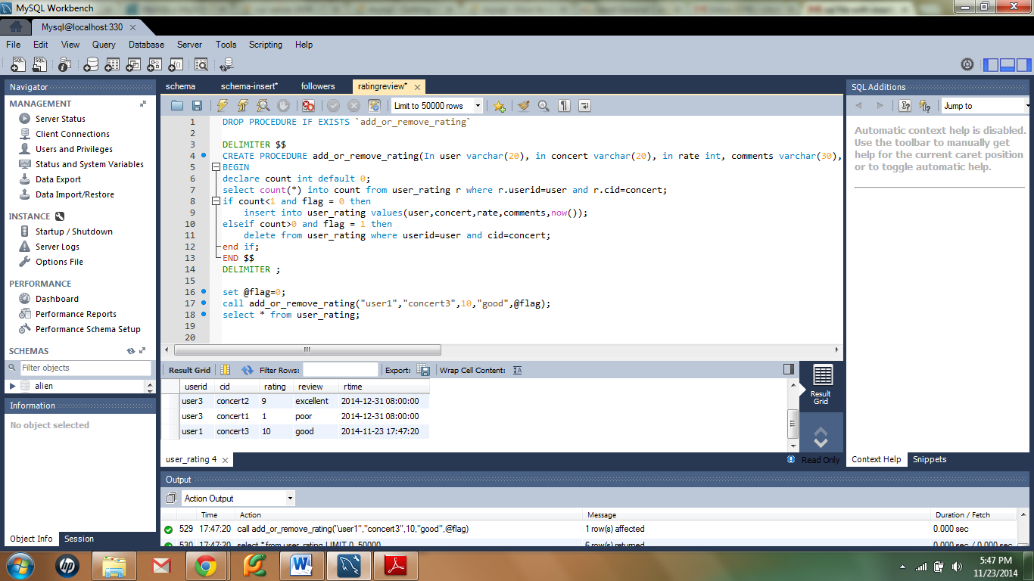

**Browse/search queries:**

select cid,ctime from concert natural join location natural join genre

where gname="jazz" and city = "brooklyn" and date(ctime) >= CURDATE() + INTERVAL 7 DAY;

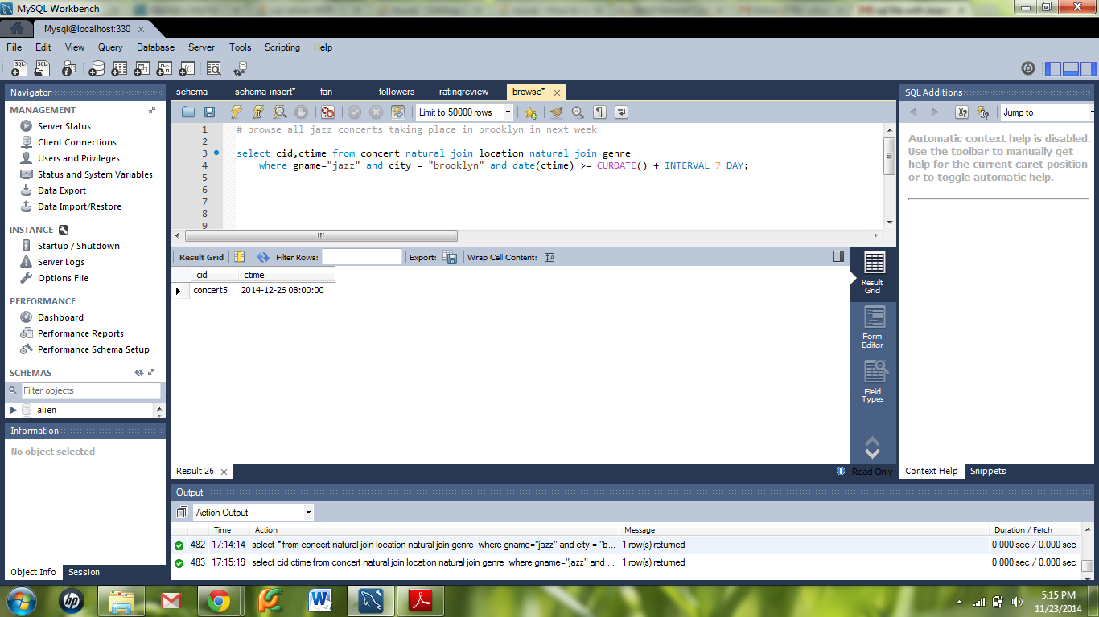

select distinct c.cid from concert c natural join rec_concert r where month(c.ctime) = month(now())+1 and r.userid in(select followingid from followers where followerid="user1");

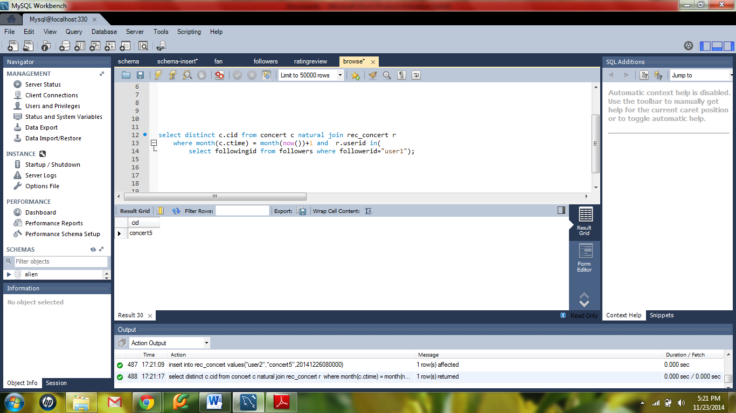

select distinct cid from concert c, user u where u.userid = "user4" and u.lastlogin < c.posttime;

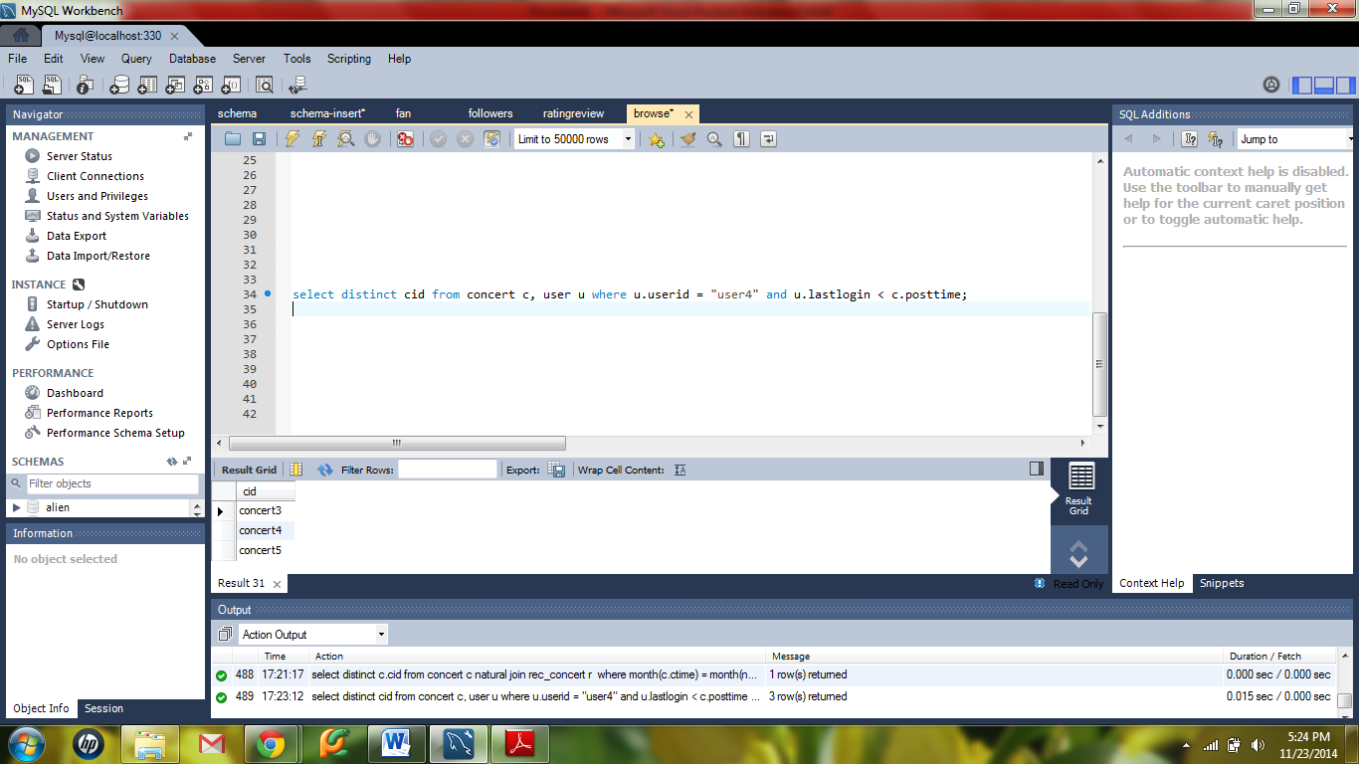

**Recommendation system:**

Query for recommending bands from genre liked by the user:

select distinct bid,bname from band natural join genre natural join genre_band natural join genre_user

where genre_user.gid="g1" and genre_user.userid="user1" group by genre.gid;

